**Aws:-**

Domain Name

General Baat:- hmara jahan code h us system ka 1 ip hoga, 127.x.x.x (anything) and usko ek name dene k liye domain name kharidna hota h (godaddy or anyone else).. chahe toh bina domain name k ip se kaam chala skte h lekin logo ko ip yaad krne m dikkat hogi.. isliye hum ek name plate bhi kharid lete h

**Ab hmme AWS server ki Jarurat kyu h?**

Suppose hmare system 1 TB hi storage h, and hmari website videos store krti h after storing some amount hme aur storage ki jarurt hogi, so then

1.Buy bigger laptop

2. buy one more laptop(space+computation) :-cons ab 2 server ho gye toh load balancer bhi bnana hoga manually taki pta kaise chale ki kis server m request krni h

3.buy external 1 tb hardisk (only space) (more I/O devices more slow system will be and more slower will be response/website)

4. suppose light chali gyi, website down (put generator)

5. heat generated in room (get AC to keep cool)

If same problem occour again than what? Take AWS

Facts:-

AWS k fayde:-

1. Agar aws ni h toh aapke system jo ki server h vo hydrabad m h and Us vale bhot user h toh udhar appki website slow ho gyi due to distance(networks hops travelled to reach response) but aws m server alag alag location pe pde rhte h

InterviewBit is Hosted on AWS Servier.

Without aws if we want to show our website to others

1. Inside local network:- use ip ya sbke pass apna local host m run krke ghume hum
2. Outside world:- use ngrok and url m ngrok lgate hi koi bhi hmari website ko host kr payega like ngrok/localhost:/fun

IaaS:- Infrastructure as a Service (matlab sara set krke dene vale jo hm apne system m krte h)

Example:- amazon aws, Microsoft azure, digital ocean

Naming: general terminology hmare setup ki IaaS providers m

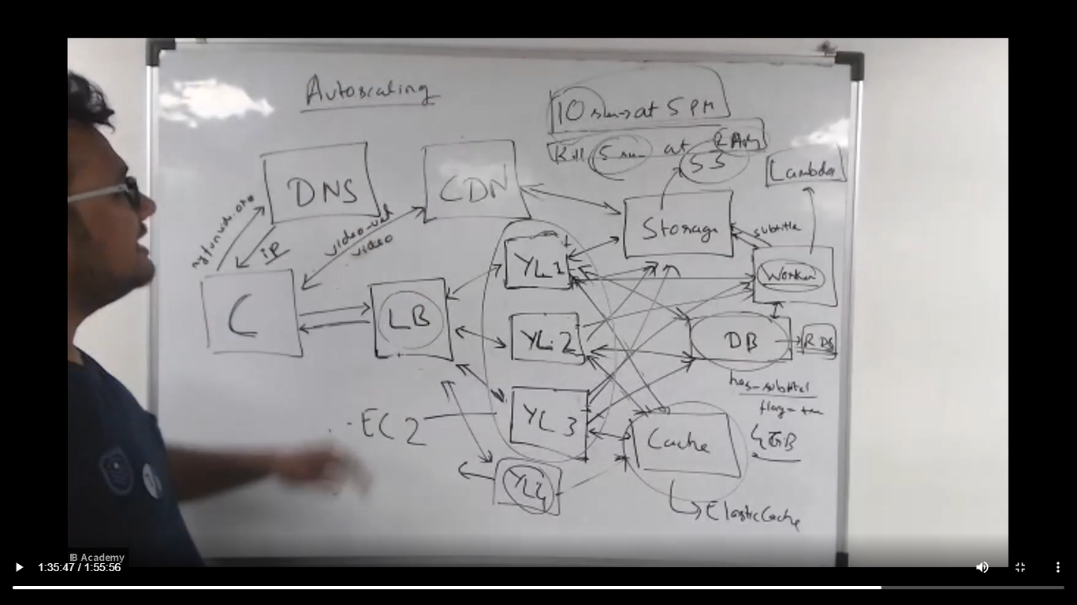

* Load balancer ko -> load balancer (same(s))
* CDN –> CDN
* Storage -> S3 (simple storage service)
* Your laptop jo as server kaam kr rhe the (YL):- EC2
* Cache -> Elastic Cache
* DB (jahan tables rkhenge)-> RDS
* Worker -> lamda function